
Cigna Open Access Plus Network

How to Find a Provider in the Open Access Plus Network
1) Go to Cigna.com and click on “Find a Doctor” which is located in the top blue ribbon | 
2) Under “How are you Covered?” click on “Employer or School” | 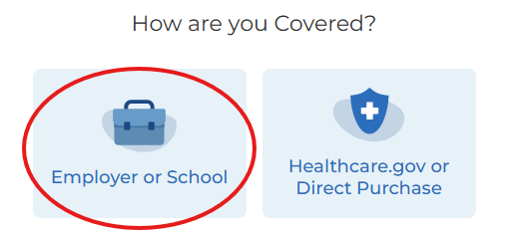
3) Enter the location in the search box. Then select the type of search you’d like to perform and follow the prompts to search for a provider | 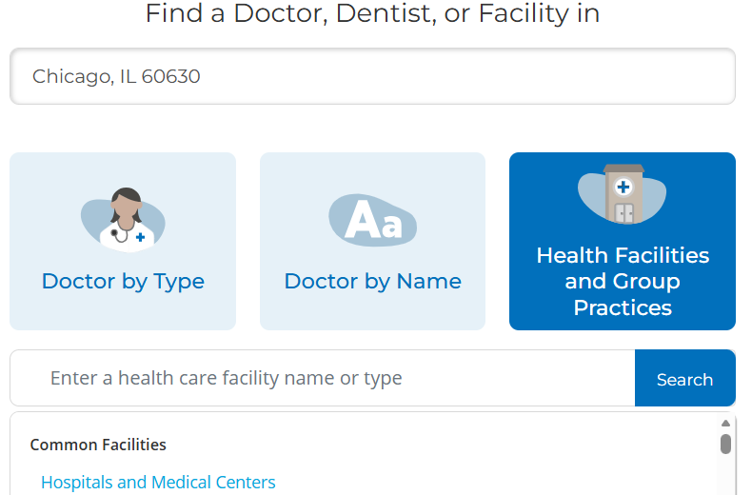
4) Continue as a guest or you can log in to your myCigna account | 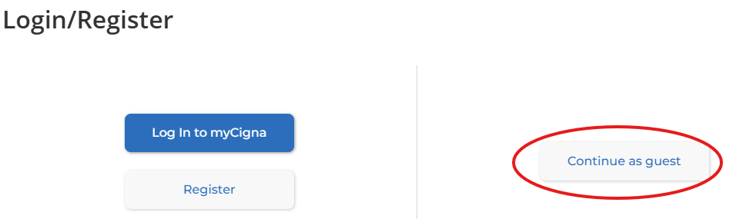
5) Confirm your location under “I Live in” and click “Continue” | 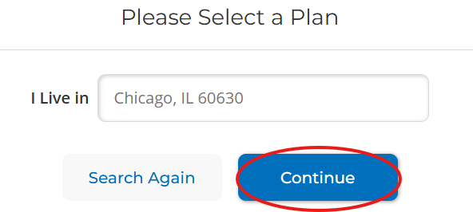
7) Choose “Open Access Plus” from the list of medical plans to see providers in the OAP network | 

