
Cigna Local Plus Network
The LocalPlus® plan consists of a collaboration of health care communities to create local networks of health care providers, specialists and hospitals that deliver value and results right where you live.
- In certain local areas, or when in any LocalPlus network area, you must receive care from a health care professional or facility in this network to receive in-network coverage.
- If you’re temporarily away from a LocalPlus network area, you can access in-network providers or hospitals through our nationwide Away From Home Care feature.
- If you choose to go outside the LocalPlus network when one is available (or outside the Away From Home Care feature when LocalPlus isn’t available), you will receive out-of-network coverage. Your share of the costs may be higher than what you would pay for in-network care.
How to Find a Provider in the Local Plus Network
1) Go to Cigna.com and click on “Find a Doctor” which is located in the top blue ribbon | 
2) Under “How are you Covered?” click on “Employer or School” | 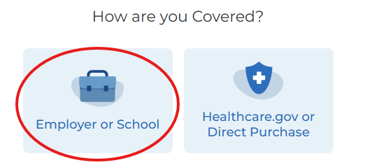
3) Enter the location in the search box. Then select the type of search you’d like to perform and follow the prompts to search for a provider | 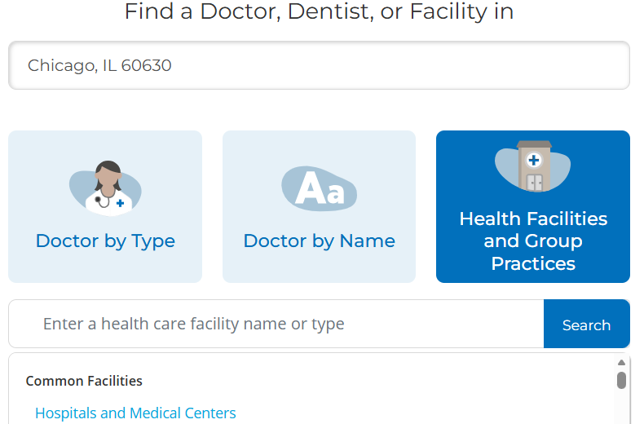
4) Continue as a guest or you can log in to your myCigna account | 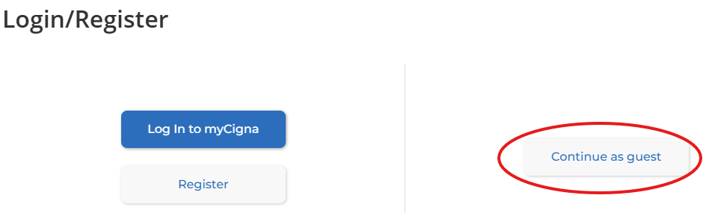
5) Confirm your location under “I Live in” and click “Continue” | 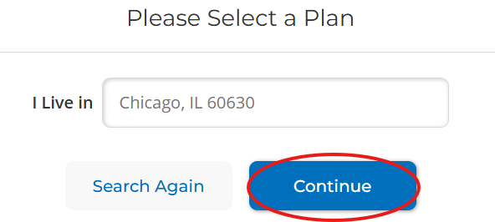
7) Choose “LocalPlus” from the list of medical plans to see providers in the LocalPlus network | 

